实验四 多表连接查询与数据库修改

姓名：王子怡 班级：软工192 学号：2019212212280

* 创建一个视图，内容包含所有课程成绩合格（成绩不为F或空）的学生姓名、课程名称、成绩

create view diss as

(select student.name,course.title,takes.grade

from (takes inner join student on takes.ID = student.ID)

inner join course on takes.course_id = course.course_id

where grade is not null or grade !=’F’);

select * from diss;

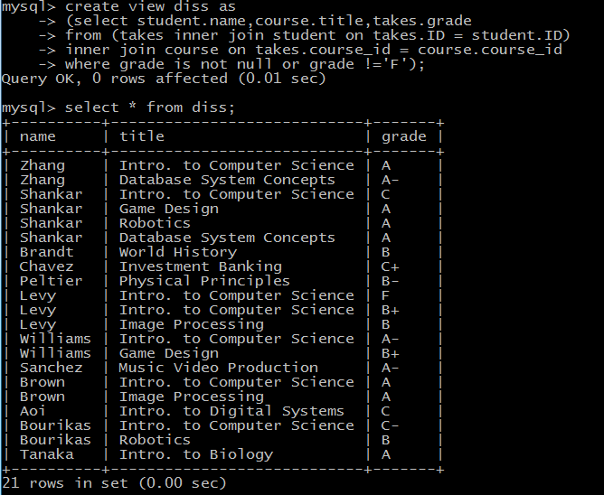

* 在上面的视图中查找所有至少有一门课程成绩为A或A-的学生姓名

select distinct name from diss where grade = ‘A’ or grade = ‘A-’;

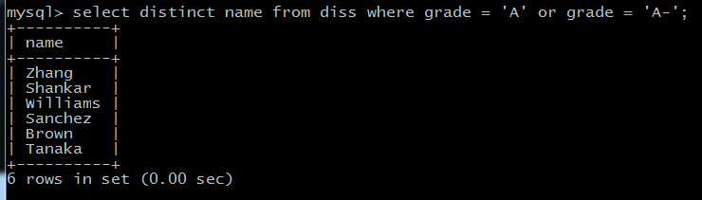

* 删除上面的视图

drop view diss;

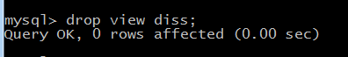

* 按以下规则修改学生的tot_cred：
  + 如果学生的tot_cred>100, 则加5分，否则减5分

update student set tot_cred = case

when tot_cred > 100 then tot_cred+5

else tot_cred -5

end;

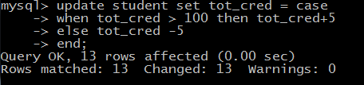

* 将student表恢复原状
  + 即如果学生tot_cred>100,减5分，否则加5分

update student set tot_cred = case

when tot_cred > 100 then tot_cred-5

else tot_cred +5

end;

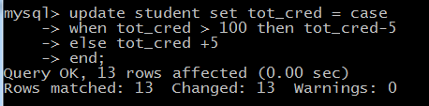

* 在student表中增加一列birthday，数据类型为date

alter table student add birthday date;

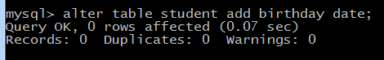

* 将所有学生的生日都设置为1990年1月1日

update student set birthday = 19900101;

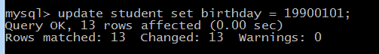

* 查看student表里的所有数据

select * from student;

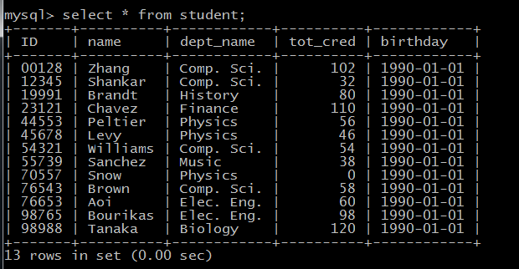

* 删除列birthday

alter table student drop column birthday;

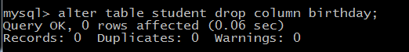

* 导入update.sql文件

source C:\Users\Administrator\Desktop\update.sql

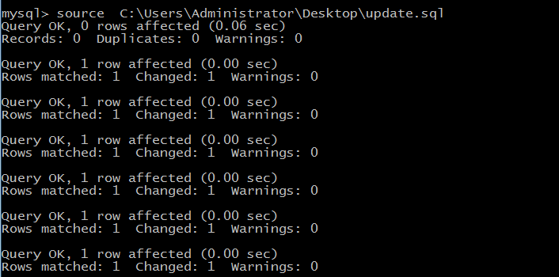

* 查找7月份出生的学生学号、姓名和所在系

select ID,name,dept_name from student where month(birthday) = ‘7’;

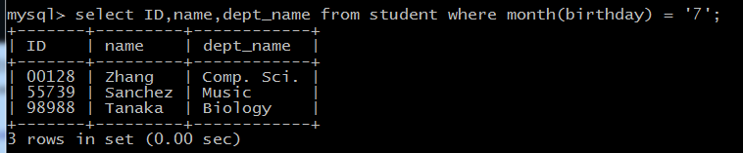

* 查找生日相同的学生和老师，打印学生和老师的姓名以及他们的出生年月日

select * from (select name,birthday from student union select name, birthday from instructor) as a

where(select count(*) from(select name,birthday from student union select name, birthday from instructor) as b

where date_format(a.birthday,'%m-%d') = date_format (b.birthday,'%m-%d'))>1

order by date_format(birthday,'%m-%d');

